Course Name: | Artificial Intelligence Laboratory | Semester: | VI
Date of Performance: | 09 / 04 / 26 | DIV/ Batch No: | A1
Student Name: | Aaryan Sharma | Roll No: | 16010123012

Experiment No: 8
Title: Implementation of Bayesian Network Using Python libraries.

Aim: Understand the inferences in uncertain scenario

Objectives of the Experiment:
By the end of this experiment, students will be able to:
- To model real-world problems using Bayesian Networks
- To perform probabilistic inference using Python libraries

COs to be achieved:
CO3: Represent and formulate the knowledge to solve the problems using various reasoning techniques

Books/ Journals/ Websites referred:
- “Artificial Intelligence: a Modern Approach” by Russel and Norving, Pearson education Publications
- “Artificial Intelligence” By Rich and knight, Tata Mcgraw Hill Publications
- https://machinelearningmastery.com/introduction-to-bayesian-belief-networks/, last retried on April 02,2025
- https://towardsdatascience.com/introduction-to-bayesian-belief-networks-c012e3f59f 1b , last retried on April 02,2025

Theory: Bayesian networks:
A Bayesian network (also known as a Bayes network, belief network, or decision network) is a probabilistic graphical model that represents a set of variables and their conditional dependencies via a directed acyclic graph (DAG). Bayesian networks are ideal for taking an event that occurred and predicting the likelihood that any one of several possible known causes was the contributing factor. For example, a Bayesian network could represent the probabilistic relationships between diseases and symptoms. Given symptoms, the network can be used to compute the probabilities of the presence of various diseases.

Efficient algorithms can perform inference and learning in Bayesian networks. Bayesian networks that model sequences of variables (e.g. speech signals or protein sequences) are called dynamic Bayesian networks. Generalizations of Bayesian networks that can represent and solve decision problems under uncertainty are called influence diagrams.

Bayesian Belief Network or Bayesian Network or Belief Network is a Probabilistic Graphical Model (PGM) that represents conditional dependencies between random variables through a Directed Acyclic Graph (DAG).

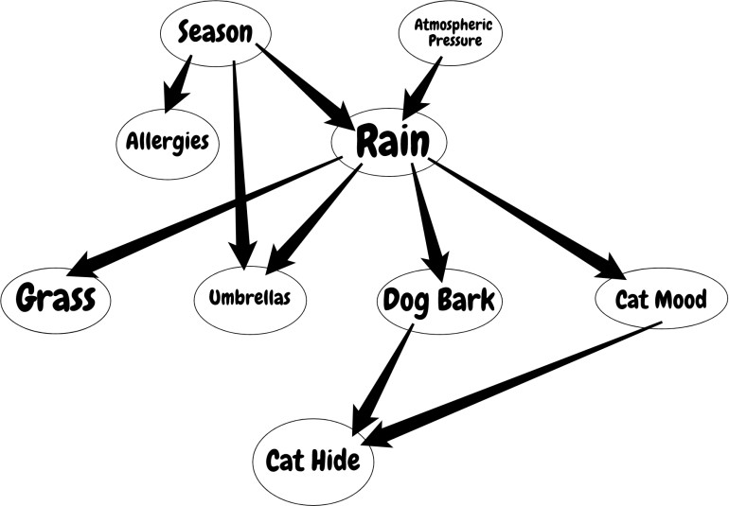

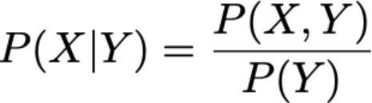
Bayesian Networks are applied in many fields. For example, disease diagnosis, optimized web search, spams filtering, gene regulatory networks, etc. And this list can be extended. The main objective of these networks is trying to understand the structure of causality relations. To clarify this, let’s consider a disease diagnosis problem. With given symptoms and their resulting disease, we construct our Belief Network and when a new patient comes, we can infer which disease or diseases may have the new patient by providing probabilities for each disease. Similarly, these causality relations can be constructed for other problems and inference techniques can be applied to interesting results.

As you would understand from the formula, to be able to calculate the joint distribution we need to have conditional probabilities indicated by the network. But further that if we have the joint distribution, then we can start to ask interesting questions. For example, in the first example, we ask for the probability of “RAIN” if “SEASON” is “WINTER” and “DOG BARK” is “TRUE”.

Activity
Chosen Problem: Software Deployment Pipeline
This problem models the deployment process of a web application where each stage may succeed or fail probabilistically. The stages include:
- Server Provisioning
- Docker Installation
- Container Building
- Application Execution
- Traffic Routing
Link to your colab notebook if you have implemented your own problem:
https://colab.research.google.com/drive/1brTAuM9q6F712P7qs_L7NsO3DXLdutmC?usp=sharing

Query 1: What is the probability of successful deployment?
Computations for query 1:
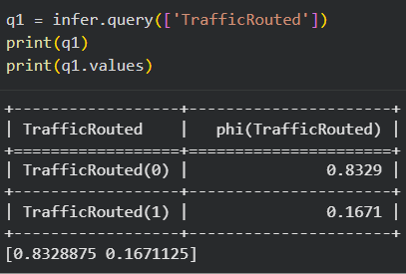

Query 2: What is the probability of success given the server is provisioned?
Computations for query 2:
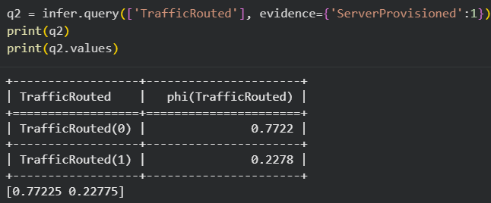

Query 3: What is the probability of success if Docker is not installed?
Computations for query 3:
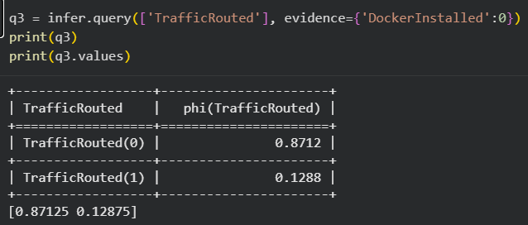

Query 4: What is the probability that the application is running given the container is built?
Computations for query 4:
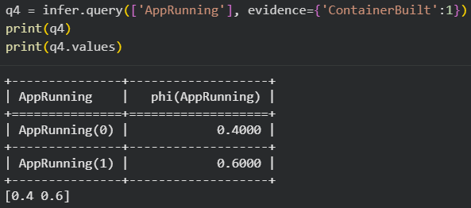

Query 5: What is the probability that the server was provisioned given deployment success?
Computations for query 5:
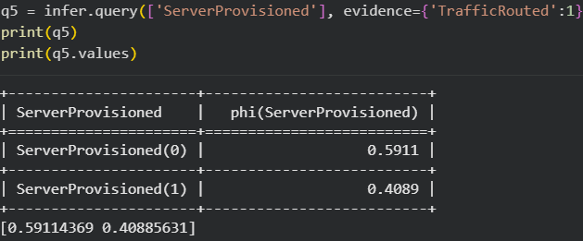

Post Lab Subjective/Objective type Questions:
Question: Answer in brief
- Explain the significance of Bayesian Networks in AI. How do they help in decision-making under uncertainty?
Bayesian Networks are important in AI because they model probabilistic relationships between variables using conditional dependencies. They help in decision-making under uncertainty by calculating the likelihood of different outcomes based on available evidence, allowing systems to make informed predictions even with incomplete data.

- What are the main components of a Bayesian Network? Explain each briefly.
A Bayesian Network consists of nodes, edges, and conditional probability tables (CPTs). Nodes represent random variables, edges represent dependencies between variables, and CPTs define the probability of each variable given its parent variables.
- What is Variable Elimination?
Variable Elimination is an inference algorithm used in Bayesian Networks to compute probabilities efficiently by eliminating irrelevant variables step by step, reducing computational complexity.
- Suppose you have a Bayesian Network with three variables: Disease, Test Result, and Symptoms. Explain how you would use conditional probabilities to determine the likelihood that a patient has the disease given a positive test result.
Using Bayes’ theorem, we compute the probability of Disease given a positive test result by combining prior probability of the disease with the likelihood of the test result given the disease. The network uses conditional probability tables to update beliefs and calculate the posterior probability.

Conclusion:
This experiment demonstrated the use of Bayesian Networks to model uncertain real-world scenarios using probabilistic reasoning. By representing dependencies through a directed acyclic graph and applying inference techniques, the experiment showed how probabilities can be updated based on evidence. The implementation using Python helped in understanding how Bayesian Networks support decision-making under uncertainty and enable efficient reasoning in complex systems.

